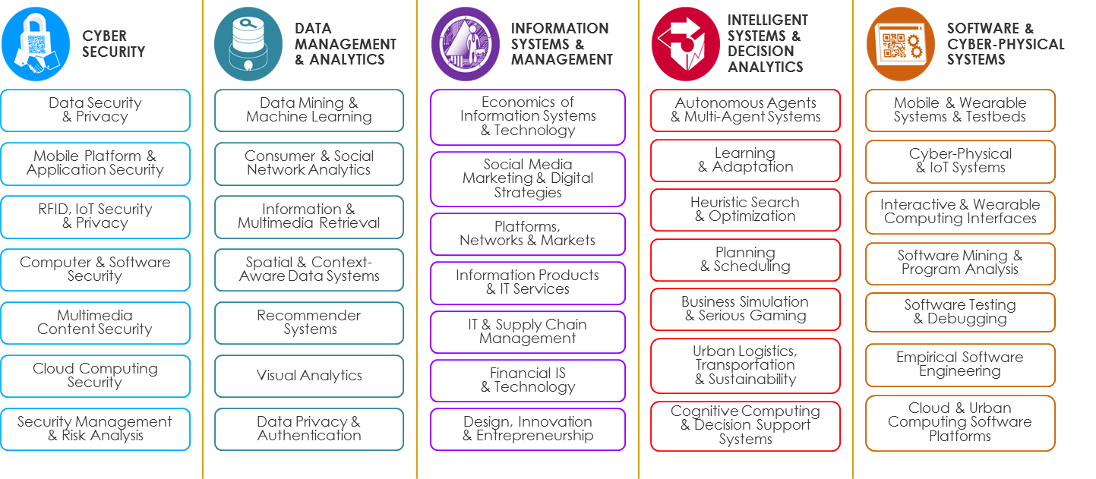
In this talk, professors from School of Information Systems (SIS) in Singapore Management University (SMU) will introduce their educational and research programmes in SIS-SMU, offering scholarships for interested and qualified students to pursue PhD degrees in various research areas in computer science and information management. After the talk, we will offer a GRE-equivalent test in free of charge for those who are interested in applying our PhD program. Every applicant will be offered a full scholarship if accepted. In addition, we have several other contract research positions, so we can do an informal interview if anyone is interested. All interested students are welcomed to attend this talk.
Talk Time: 2015, October 5th, 10:00 AM (TBC)
Talk Venue: Meeting Room (TBC)

